

AMITY UNIVERSITY BENGALURU

## SOURCE CODE MANAGEMENT

**Submitted To:**

Dr. Monit Kapoor

**Submitted By:**

Seema Sharma

**Submission date:**

10/6/2025

**SEN :**

A866181524007

**Course slot:**

L5+6

**Course:**

B-Tech-Es and VLSI, 2nd Sem

## Aim: Installation and configuration of gitbash and GitHub

1. Download Git for Windows Navigate to the official Git website and download the installer for Windows.

Navigate to the official Git website and download the installer for Windows.

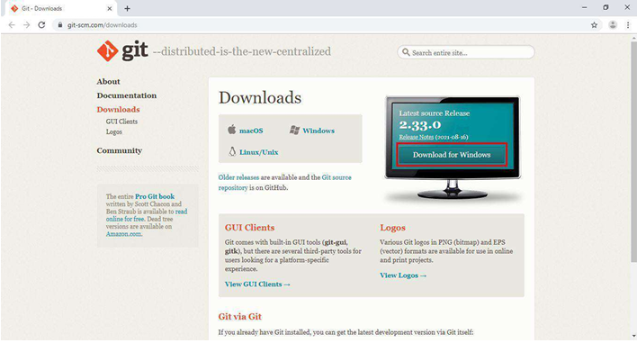

1. License Agreement

Upon running the installer, you'll be presented with the GNU General Public License. Accept the agreement to proceed.

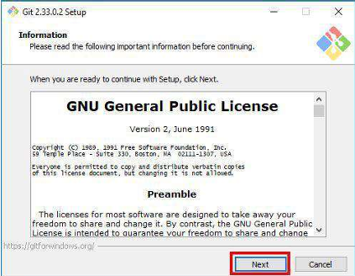

1. Select Installation Folder

Choose the directory where Git will be installed. The default path is usually sufficient.

1. Select Components

Select the components you wish to install. It's recommended to leave the default selections unless you have specific requirements.

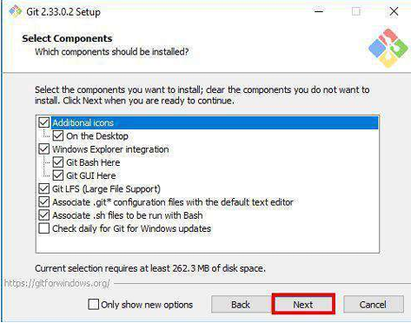

1. Choose Start Menu Folder

Decide on the Start Menu folder name where Git shortcuts will be placed.

1. Choosing the Default Editor

Select the default text editor for Git. Visual Studio Code is a popular choice.

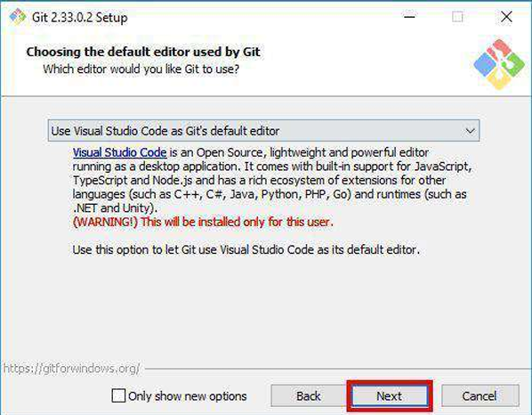

1. Adjusting the Name of the Initial Branch

Set the default branch name for new repositories. "main" is commonly used.

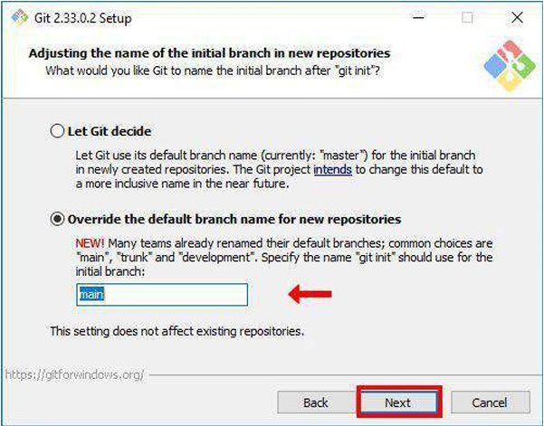

1. Adjusting Your PATH Environment

Choose how Git will be integrated into your system's PATH. The recommended option allows Git to be used from the command line and third-party software.

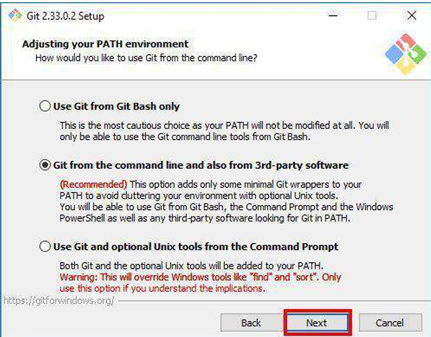

1. Choosing HTTPS Transport Backend

Select the HTTPS transport backend. Using the OpenSSL library is the default and recommended option.

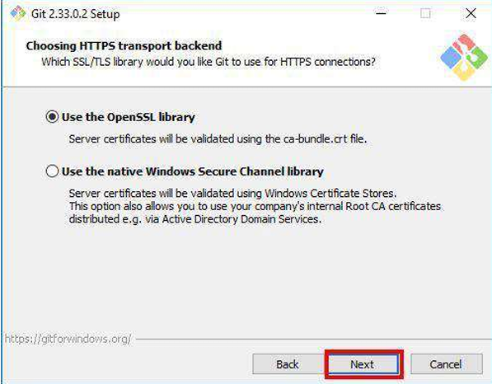

1. Configuring the Line Ending Conversions

Decide how Git will handle line endings. The default setting is suitable for most users.

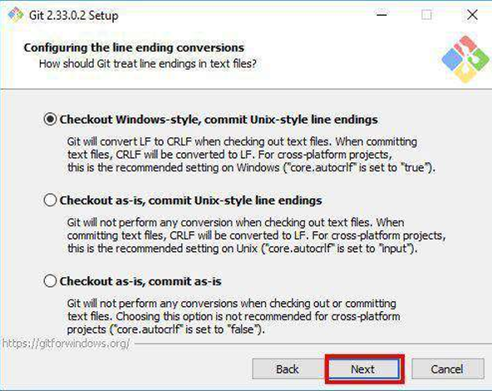

1. Configuring the Terminal Emulator

Choose the terminal emulator for Git Bash. The default MinTTY is recommended. emulator. It helps in executing Git commands and using Unix-style commands on Windows.

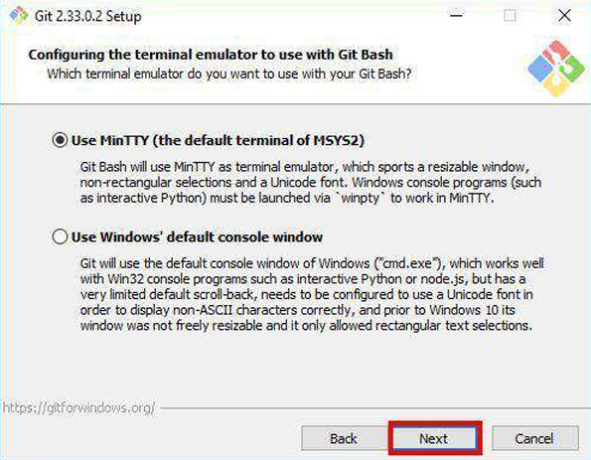

1. Configuring Extra Options

Select any additional options as needed. The defaults are generally appropriate.

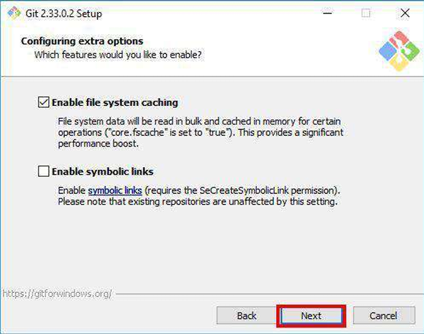

1. Installing Git

Click "Install" to begin the installation process.

1. Completing the Installation

Once the installation is complete, git bash can be launched .

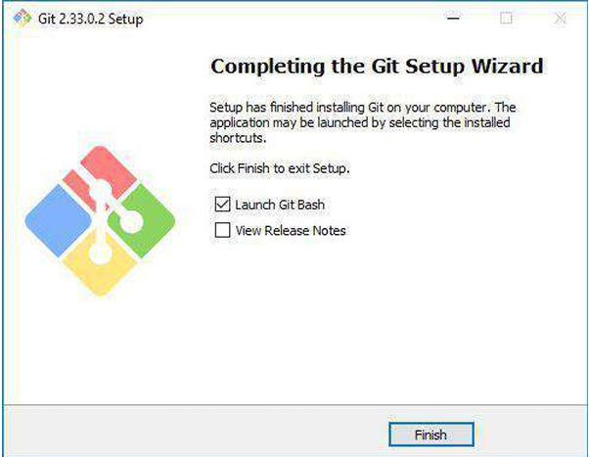

**(OR )**

**Procedure To Download Can be done From Command Prompt if the GitBash is already been Installed**

**Aim:**  
To install Git Bash on a Windows system for version control operations.

**Theory:**  
Git Bash is an application that provides Git command line features along with a Base

**Software Requirements:**

* Windows OS
* Internet Connection

**Procedure:**

1. Visit the official Git website: <https://git-scm.com/>
2. Click on **"Download for Windows"**.
3. Run the downloaded .exe file.
4. Follow the installation wizard:
   * Choose default options unless specific preferences are needed.
   * Select “Use Git from the command line and also from 3rd-party software”.
5. Finish installation and launch **Git Bash**.
6. Check the version using the command:

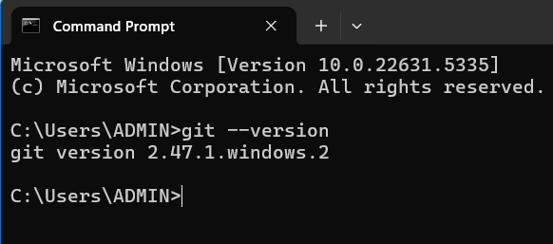

**Result:**  
Git Bash was successfully installed and launched.

**Program 2: Configure GitHub in Git Bash**

**Aim:**  
To configure GitHub account details in Git Bash for using Git version control.

**📚 Theory:**

Git needs to know who you are so that it can track who made which changes. To use GitHub with Git Bash, we need to set the global username and email, which should match your GitHub account.

**🛠️ Software/Tool Requirements:**

* Git Bash (already installed)
* GitHub account (created)
* Internet Connection

**📋 Procedure:**

1. **Open Git Bash.**
2. Set your GitHub username by entering the following command:

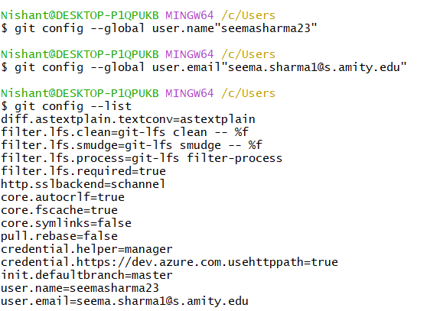

**Result:**

GitHub account has been successfully configured in Git Bash with username and email.

**Program 3: Initialize a Git Repository**

**Aim:**  
To initialize a Git repository in a local project directory using Git Bash.

**Theory:**  
Git needs to be initialized in a project folder to start tracking changes using version control. The git init command sets up the folder as a Git repository.

**Procedure:**

1. Open Git Bash.
2. Navigate to your project folder:

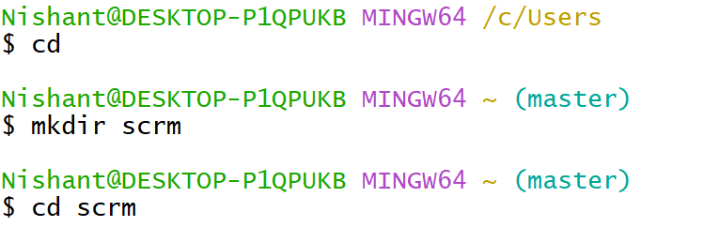

3.Initialize Git:

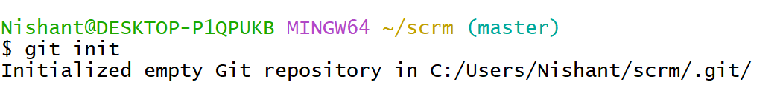

**Result:**  
A new Git repository was initialized successfully.

**Program 4: Check Current Branch (master)**

**Aim:**  
To verify the active Git branch after initialization.

**Theory:**  
Every Git repository starts with a default branch. In most systems, this is master unless changed manually.

**Procedure:**

1. In the initialized Git repository, run:

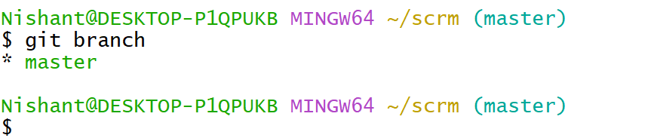

**Result:**  
The current branch is displayed as master.

**Program 5: Add Files to Git Staging Area**

**Aim:**  
To stage files for the next commit in Git.

**Theory:**  
Before committing, files must be added to the **staging area** using git add. This tells Git which files to track for the upcoming commit.

**Procedure:**

1. Create a file (optional step, like index.html).
2. Run:

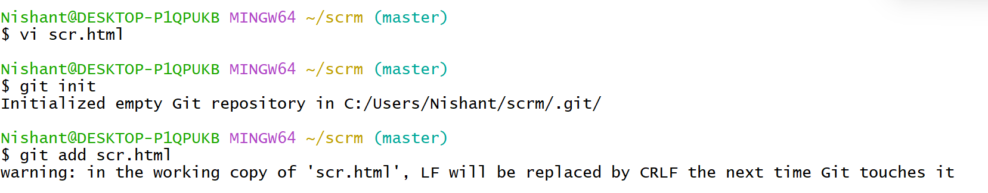

**Result:**  
Files added to the staging area.

**Program 6: Commit Files in Master Branch**

**Aim:**  
To create a commit with a meaningful message on the master branch.

**Theory:**  
A commit is a saved version of your code at a specific time. Commits help track changes and roll back if necessary.

**Procedure:**

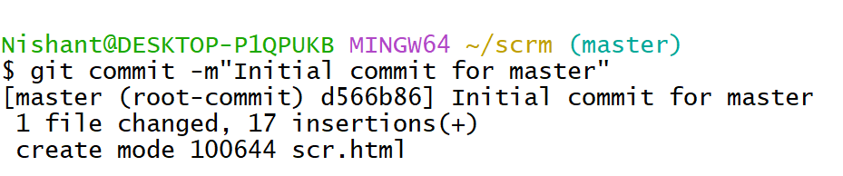

**Result:**  
Files committed successfully to the master branch.

**Program 7: Create and Switch to dev Branch**

**Aim:**  
To create and move to a new branch named dev.

**Theory:**  
Branches allow developers to work on features without affecting the main/master branch. This helps in parallel development and testing.

**Procedure:**

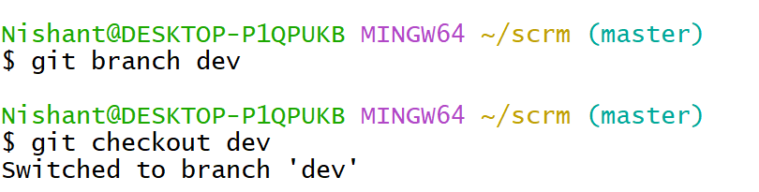

**Result:**  
New dev branch created and activated.

**Program 8: Add and Commit in dev Branch**

**Aim:**  
To add and commit changes on the dev branch.

**Theory:**  
Each branch can have its own independent commits. This allows working on updates without touching the master.

**Procedure:**

1. Make or modify a file.
2. Add and commit:

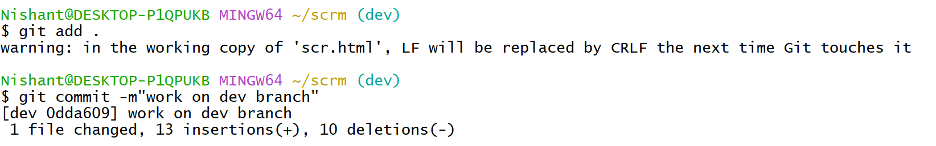

**Result:**  
Changes added and committed in dev branch.

**Program 9: Connect Local Repo to Remote GitHub Repo**

**Aim:**  
To add a remote repository link to the local Git project.

**Theory:**  
Remote repositories on GitHub allow code sharing and collaboration. The origin is the name given to the main remote URL.

**Procedure:**

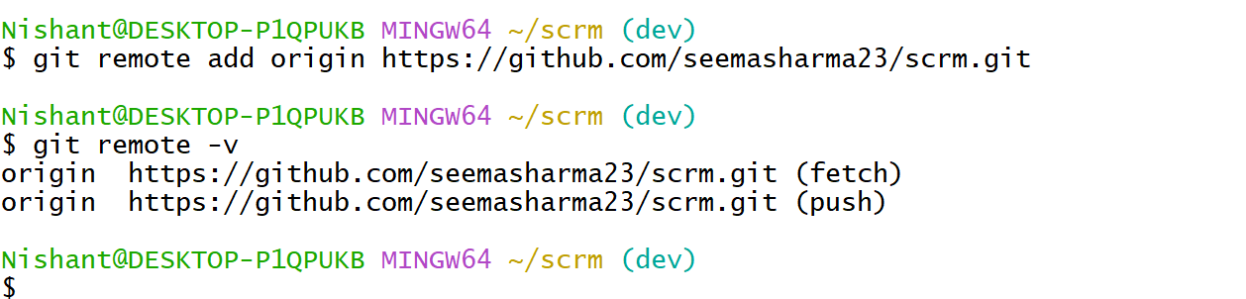

**Result:**  
Remote origin added pointing to GitHub repo.

**Program 10: Push dev and master Branch to GitHub**

**Aim:**  
To push both dev and master branches from the local repository to the remote GitHub repository.

**Theory:**  
Pushing sends your committed work from your local machine to GitHub. It helps back up your work and collaborate with others. You can push multiple branches individually using the git push command.

**Procedure:**

1. ✅ **Push the dev branch**

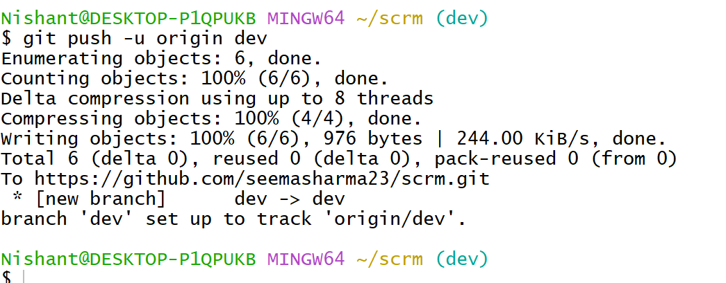

1. 🔁 **Switch to the master branch**:

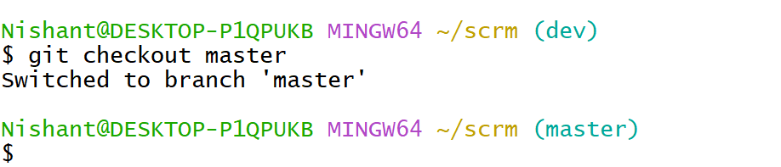

1. ✅ **Push the master branch**:

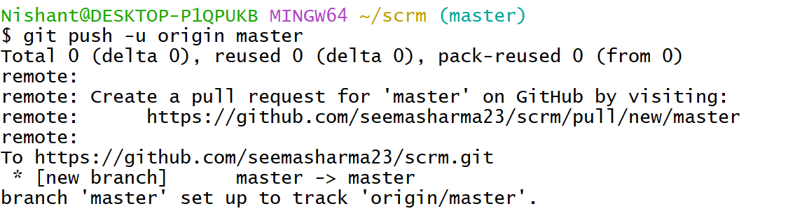

**Result:**  
Both the dev and master branches have been successfully pushed to the GitHub repository.

**Program 11: Merge dev into master**

**Aim:**  
To merge changes from dev into master.

**Theory:**  
Merging brings changes from one branch into another.

**Procedure:**

1. Ensure you're on master

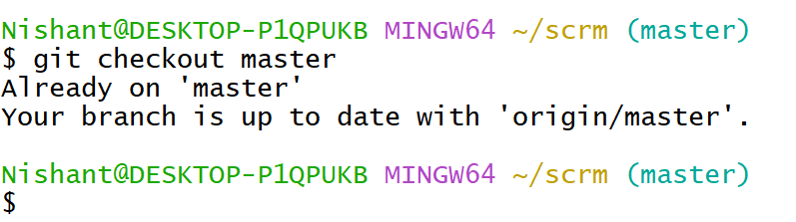

1. Merge dev:

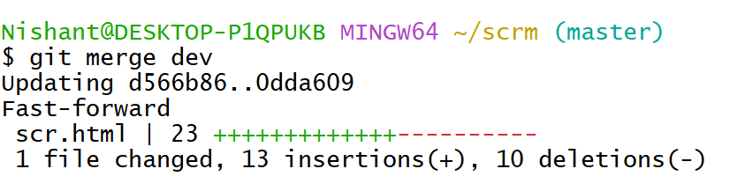

1. Push updated master:

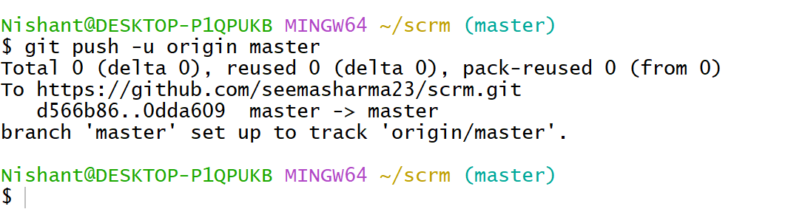

**Result:**  
dev merged into master and pushed.

**Program 12: Fork a Repository on GitHub**

**Aim:**  
To fork a public GitHub repository.

**Theory:**  
Forking copies a repo into your GitHub account.

**Procedure:**

1. Open the original repo on GitHub.
2. Click **Fork** on the top right.

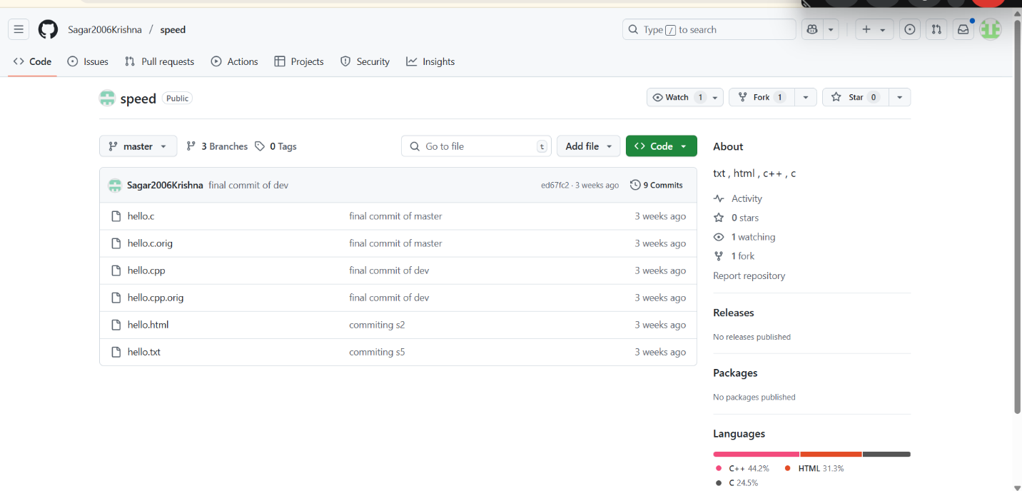

**Result:**  
Repository forked successfully.

**Program 13: Clone Forked Repository**

**Aim:**  
To clone the fork to your system.

**Theory:**  
Cloning brings all project files locally.

**Procedure:**

1. Copy repo URL.
2. Run:

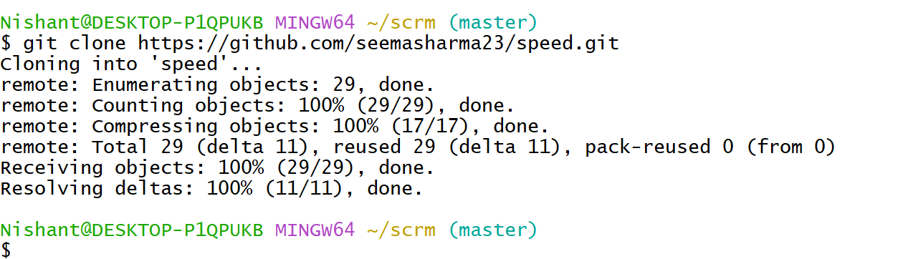

**Result:**  
Repo cloned to local system.

**Program 14: Create Feature Branch**

**Aim:**  
To create a new branch for changes.

**Theory:**  
Useful for feature development.

**Procedure:**

1. Run:

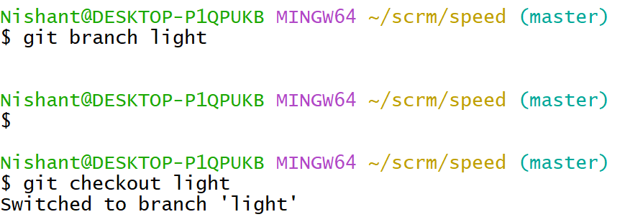

**Result:**  
Feature branch created.

**Program 15: Commit in Feature Branch**

**Aim:**  
To commit updates in feature branch.

**Theory:**  
Keeps features separate until ready.

**Procedure:**

1. Make changes.
2. Run:

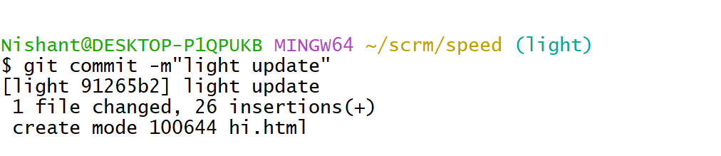

**Result:**  
Changes committed in feature branch.

**Program 17: Push Feature Branch**

**Aim:**  
To push feature branch to GitHub.

**Theory:**  
Allows others to view/test your changes.

**Procedure:**

1. Run:

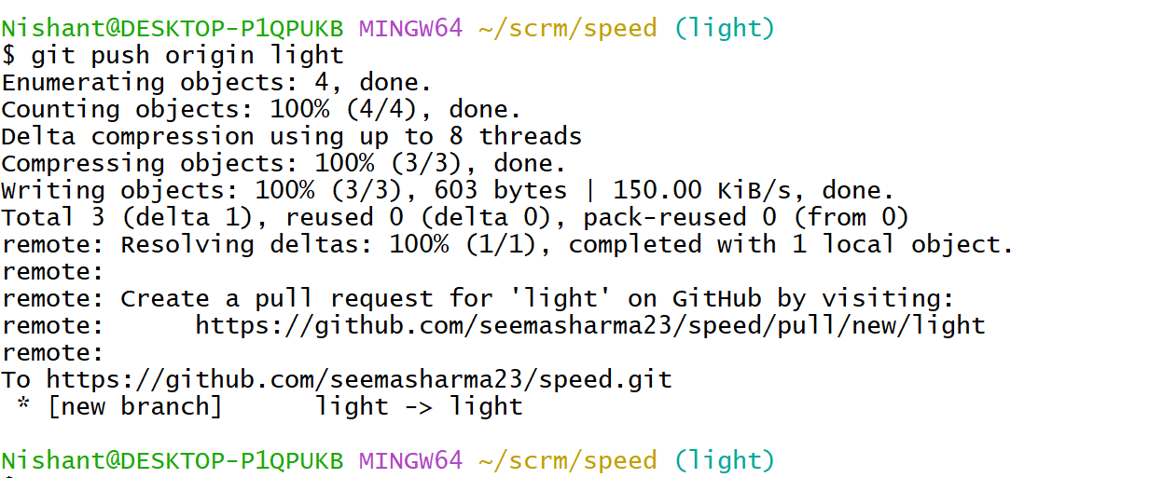

**Result:**  
Feature branch pushed.

**Program 18: Open Pull Request**

**Aim:**  
To request merging feature branch.

**Theory:**  
Pull requests are collaboration tools.

**Procedure:**

1. Go to your repo on GitHub.
2. Click **Compare & Pull Request**.
3. Add title and comment, then click **Create Pull Request**.

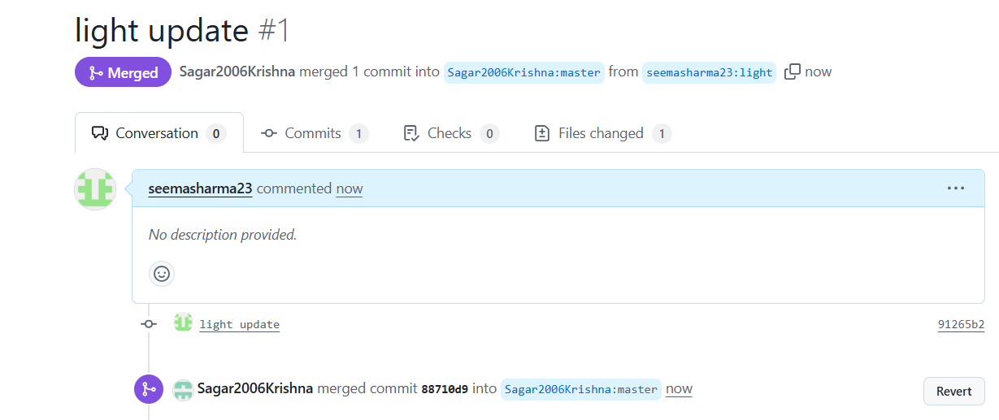

**Result:**  
Pull request created.

**Program 19: Merge Pull Request**

**Aim:**  
To merge a pull request.

**Theory:**  
Allows integrating approved changes.

**Procedure:**

1. Go to the PR.
2. Click **Merge Pull Request** > **Confirm Merge**.

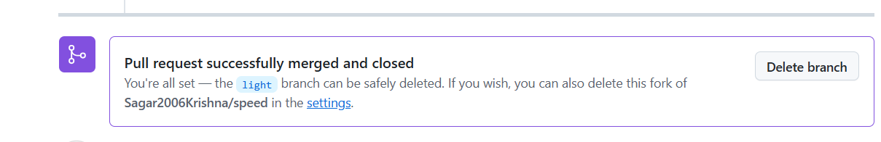

**Result:**  
Pull request successfully merged.

**Program 20: Pull Latest Changes from GitHub**

**Aim:**  
To sync local repo with remote.

**Theory:**  
git pull fetches and merges latest changes.

**Procedure:**

1. Run:

